**Measurements Report**

**(All equipment data and theoretical calculations are based on Nicolay's preliminary work)**

1. ***General:***
   * Date: 8/5/2016
   * Participants: Nicolay Tal, Yuval Ben Hur, Lior Kissos
   * Location: Technion EE faculty, Communication Laboratory
2. ***Equipment*** 
   * Transmitter:
     + Tx coil: FESP 5133-1330
       - L=485uH
       - Diameter: 0.5 m
       - Isat=7 Amp
       - Nwindings=20
     + Amplifier: AE Te6
     + AE Techron 2105
       - Vmax=150 v_peak
       - Zout=28mOhm
       - Gain=[0.2,20]V/V
   * Receiver:
     + Sensor: Metronix SHFT-02e
       - Sensitivity=0.05 v/nTesla
       - Flatness~ up to 30kHz
       - Noise floor (reflected to input)=8e-6 nTesla/sqrt(Hz)
   * Test equipment:
     + Arbitrary waveform generator
     + Oscilloscope
     + Spectrum Analyzer (X-series CXA)
     + DC power supply
3. ***Theoretical Background (Nicolay)***
   * Tx Magnetic induction: 
   * Tx Magnetic field: 
   * Rx transfer function: 
4. ***Setup***



1. ***Experiment no. 1:*** 
   * Conditions:
     + short range: 1 m
     + coaxial mutual positioning of Tx and Rx coils
     + Frequency=8.5kHz
   * Setup:

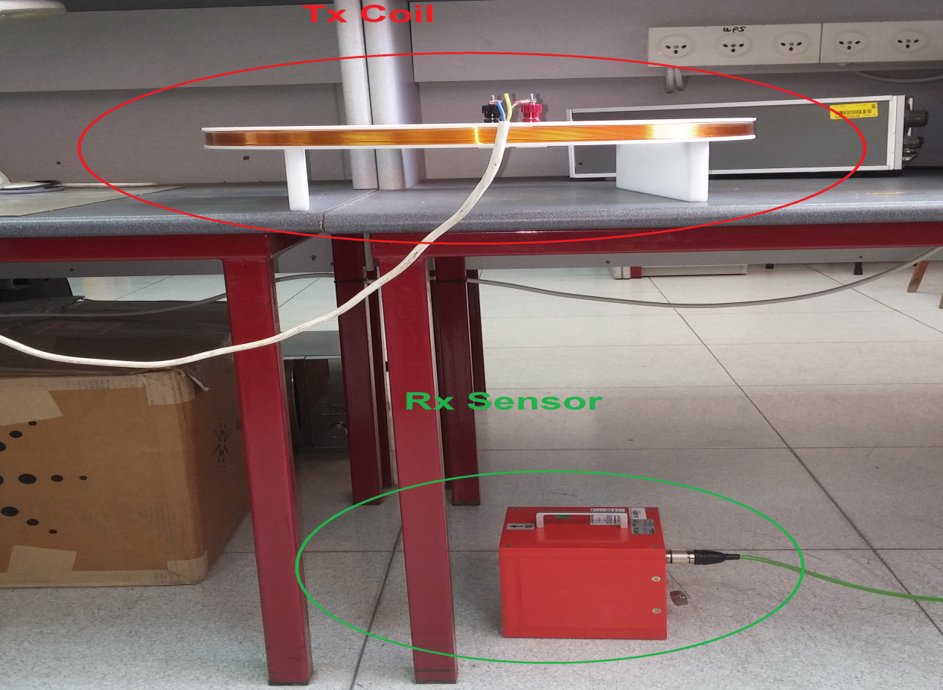

* + Theoretical Calculation:
    - Current RMS= 
    - Magnetic field (vacuum medium)
    - Rx Sensor output power=
  + Measured results: 14dBm!

(Following pictures were taken at a lower current configuration)

* Small span

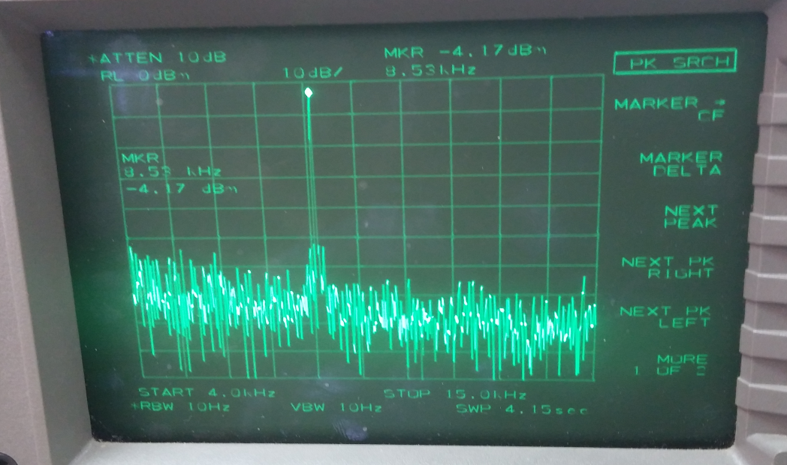

* Large span:

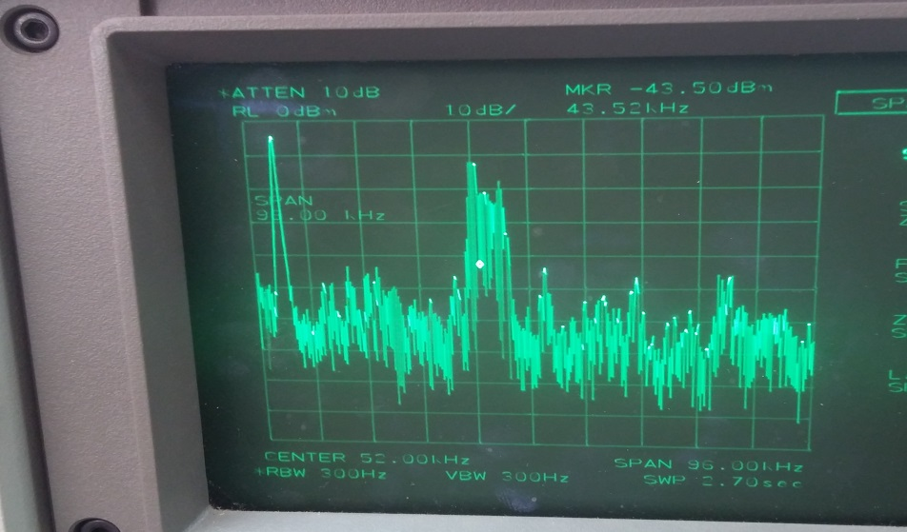

1. ***Experiment no. 2:*** 
   * Conditions:
     + short range: 10 m
     + 2 walls
     + ~coaxial mutual positioning of Tx and Rx coils
     + Frequency=[10,20] kHz in 1kHz resolution
   * Setup:
     + Transmitter- room #1

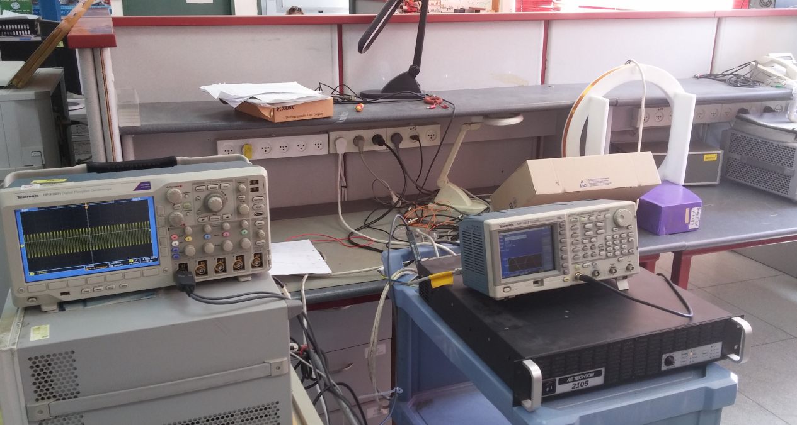

* + - Receiver: room # 2

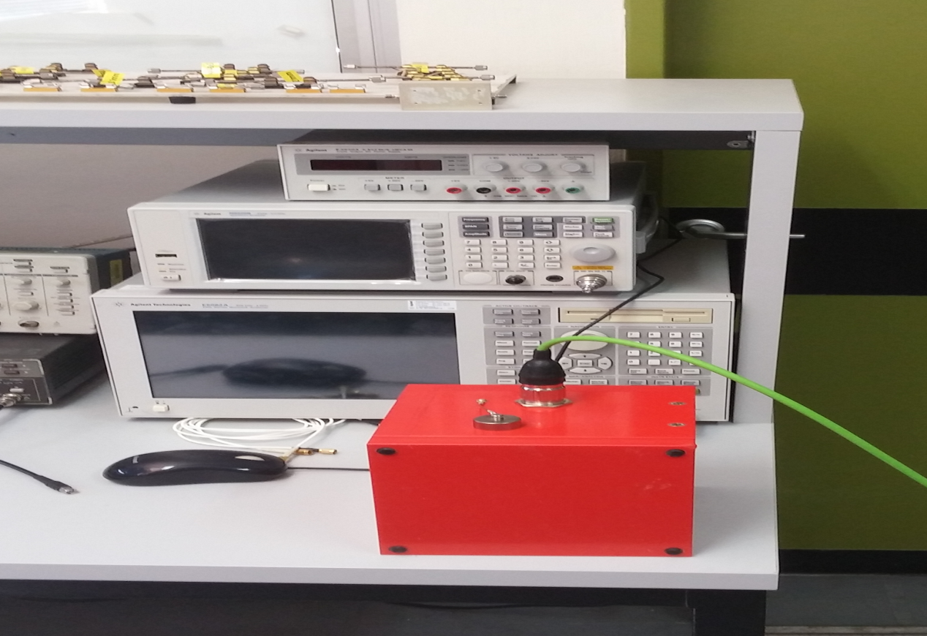

* + Theoretical Calculation :
    - Current RMS= 
    - Magnetic field (vacuum medium )=
    - Rx Sensor output power=
  + Measured results: [-10,-12]dBm

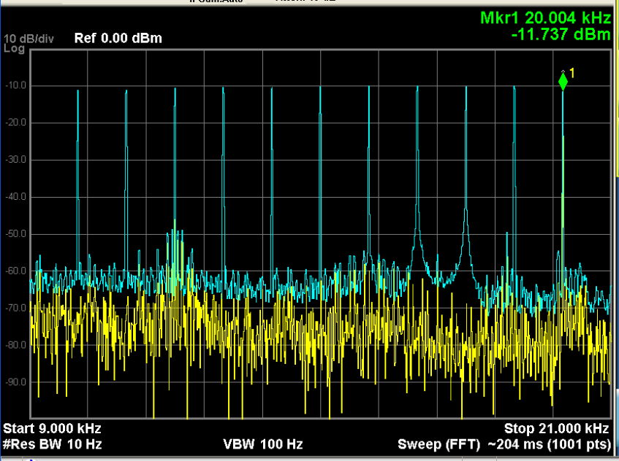

1. ***Conclusions:***
   * Measured results match theoretical calculations (vacuum medium) quite well. Hence, 100m range is expected to decrease output power by 60dB with regard to 2nd experiment results.
   * Tx and Rx basic hardware (coil, amplifier and sensor) show a flat frequency response at [10,20]kHz, which drives us to transmit a 10kHz wide signal centered at 15kHz
   * Preliminary spectrum monitoring needs to be done prior to transmission, since VLF spectrum seems to be densely occupied
   * Apart from A/D and D/A, peripheral analog active hardware based on OpAmps will be needed:
     + Reconstruction filter
     + Anti aliasing filter
     + Low noise Rx amplifier